23CSE202 DATABASE MANAGEMENT SYSTEMS
S3 B.Tech CSE
Department of Computer Science and Engineering
Amrita School of Computing, Amritapuri Campus

PROJECT REPORT

Group No : D16
Team Members :
Roll No | Student Name
AM.SC.U4CSE25301 | Amrithalekshmy G
AM.SC.U4CSE25305 | Arya S
AM.SC.U4CSE25316 | Ganga T Viswakumar
AM.SC.U4CSE25317 | Gloria S Mathew

Project Title : Personal Expense Tracker

CONTENTS
Sl. No | Chapter | Page No
1 | Abstract
2 | Introduction
3 | Requirements (Functional & Non-functional)
4 | UI Design
5 | Database Design
6 | Database Selection & Justification
7 | Implementation
8 | Testing & Validation
9 | Results & Screenshots
10 | Challenges faced & solutions
11 | Conclusion & future enhancements
12 | References

1. Abstract
Managing personal finances efficiently is essential for maintaining financial stability, yet many individuals find it difficult to track daily expenses, organize income, and monitor their spending against a budget. Manual records and basic spreadsheet-based methods can lead to data duplication, calculation errors, and difficulties in generating meaningful financial summaries. The Personal Expense Tracker is a database-driven web application designed to simplify financial record management by providing a centralized platform for recording income and expenses, organizing transactions into categories, setting budgets, and generating financial reports. The system uses PostgreSQL as its relational database management system, Python for backend processing, and React for the user interface. The database consists of four principal tables: Users, Categories, Transactions, and Budgets. Primary keys, foreign keys, uniqueness constraints, validation rules, and indexes are used to maintain data integrity and improve query efficiency. The system supports user authentication, transaction insertion and modification, category management, budget monitoring, and the retrieval of financial summaries. By applying relational database design principles, functional dependencies, and normalization, the proposed application aims to reduce redundancy, maintain consistency, and provide reliable access to financial information. The expected outcome is a secure, user-friendly, and maintainable application that helps individuals understand their spending patterns, monitor financial goals, and make better-informed financial decisions.

2. Introduction
Managing personal finances is important for understanding spending habits and planning expenses. People often spend money on food, travel, education, shopping, and other daily needs. Without proper records, it can become difficult to remember where money was spent or determine how much is left for the rest of the month.
Many people use notebooks or spreadsheets to record their expenses. These methods work for basic tracking, but calculations and updates have to be handled manually. Records may become disorganized, and preparing monthly summaries or comparing expenses across categories can take additional time. It is also difficult to maintain consistent category names and relationships between records.
The Personal Expense Tracker is designed to address these problems through a database-based web application. Users can record income and expenses, organize transactions into categories, create budgets, and view summaries of their financial activities. The system stores this information in PostgreSQL, allowing records to be retrieved and updated whenever required.
The application has three main components. React provides the user interface, the Python backend processes requests and applies application rules, and PostgreSQL stores the data. The backend acts as the connection between the interface and the database.
The main objective of the project is to provide a simple way to maintain financial records and monitor spending. It also demonstrates the use of relational database concepts such as table relationships, primary keys, foreign keys, functional dependencies, and normalization.

3. Requirements
Functional Requirements
- Users should be able to register and log in securely.
- Users should be able to add, edit, delete, and view income and expense transactions.
- Transactions should be organized into categories such as food, travel, education, and salary.
- Users should be able to create and manage budgets for selected categories and periods.
- The system should allow users to search and filter transactions by date, category, and transaction type.
- The dashboard should display financial summaries, including total income and total expenses.
- The system should generate reports that help users understand their spending patterns.
- The application should validate user inputs before storing them in the database.
Non-Functional Requirements
- Security: Passwords must be stored as hashes, and users should only access their authorized records.
- Performance: Transactions and reports should be retrieved within a reasonable time.
- Reliability: The database should maintain accurate and consistent records.
- Usability: The interface should be simple to navigate and understand.
- Maintainability: The frontend, backend, and database should be organized separately.
- Scalability: The database design should support an increase in users and transactions.
4. UI Design
The Personal Expense Tracker provides a simple interface for managing financial records. The application is developed using React, with separate screens for account access, transactions, categories, budgets, and reports.
Login and Registration: Users can log in with their credentials or create a new account by providing the required details.
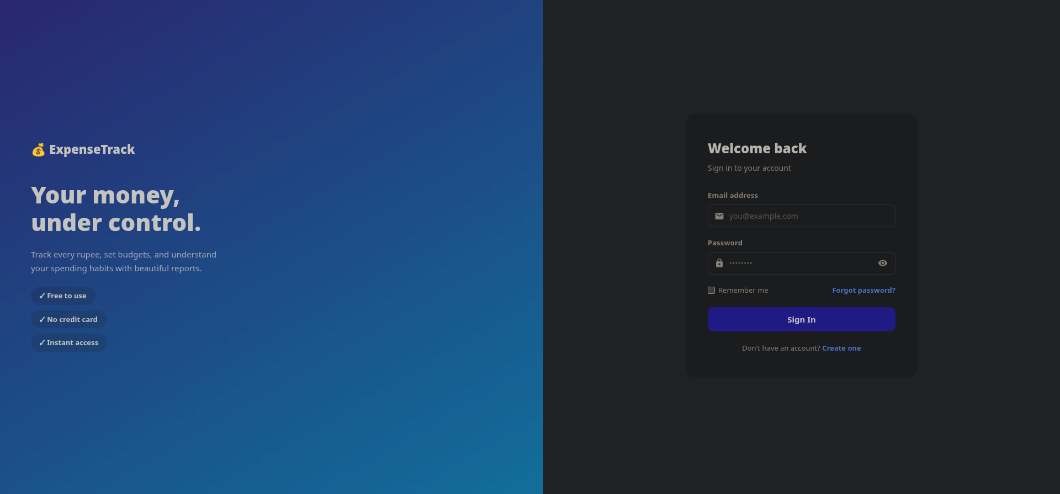
Dashboard: Displays a summary of total income, expenses, current balance, and recent transactions.
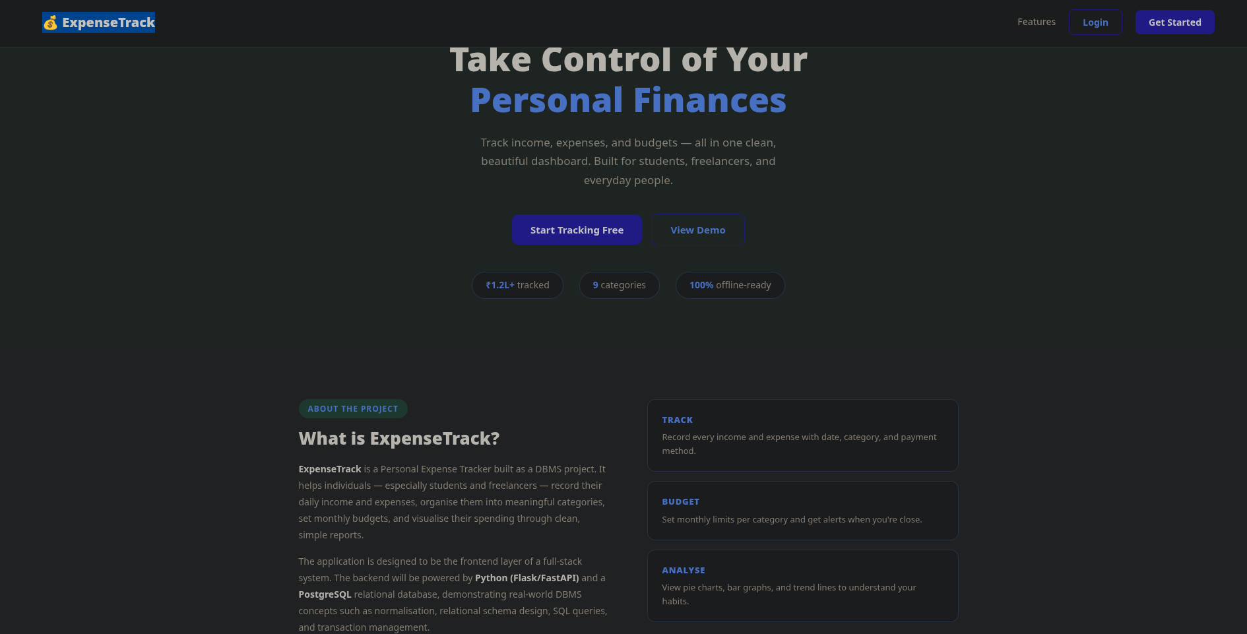
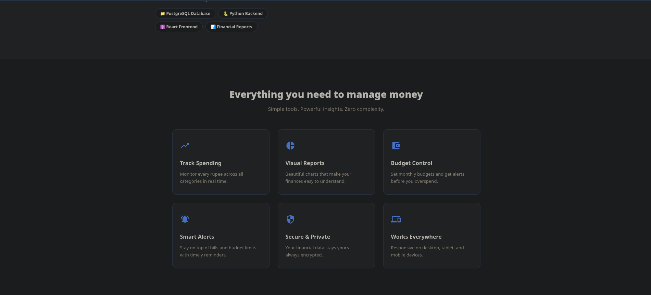
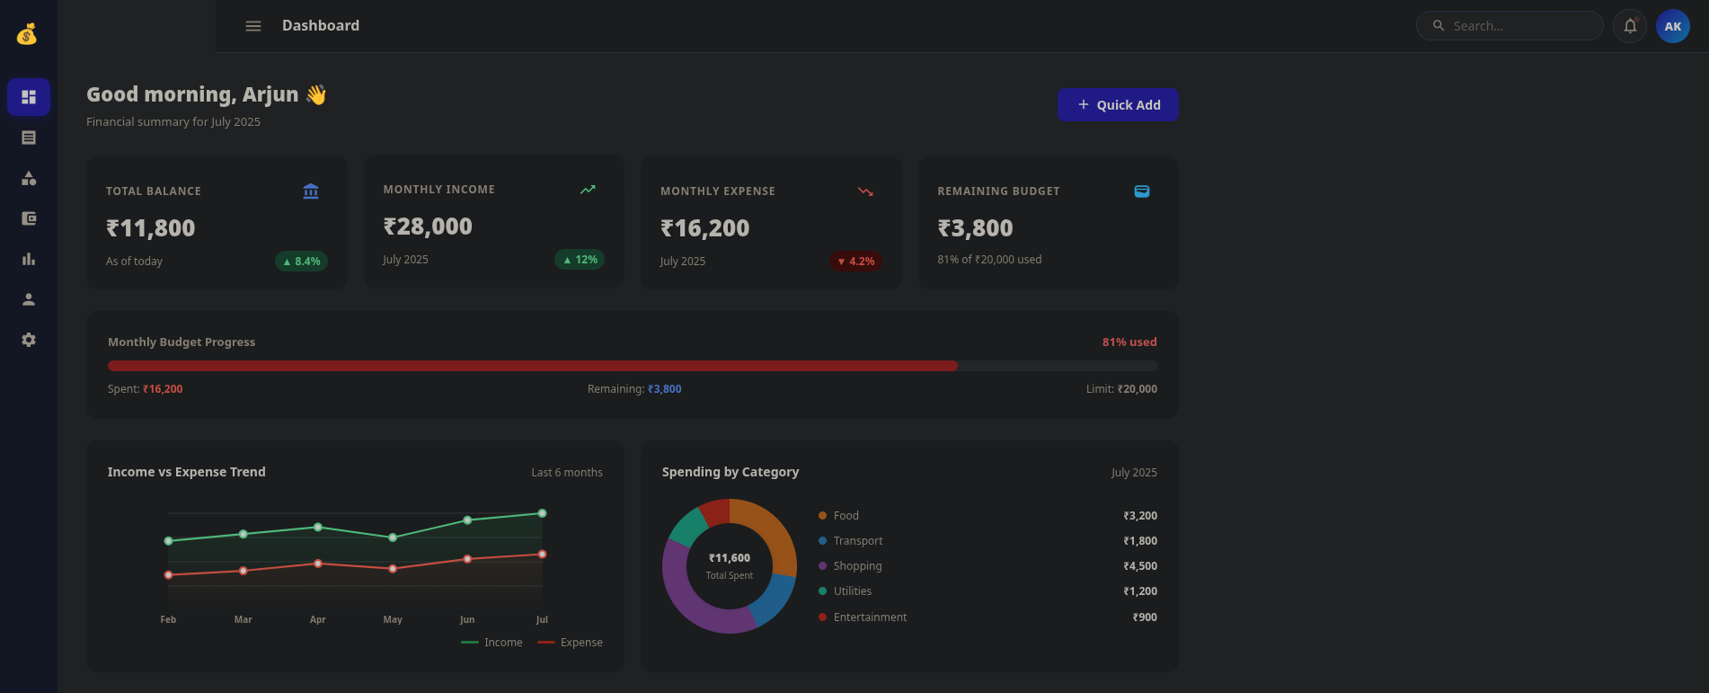
Transaction Management: Allows users to add, view, edit, and delete income and expense records by entering the amount, category, date, and description.
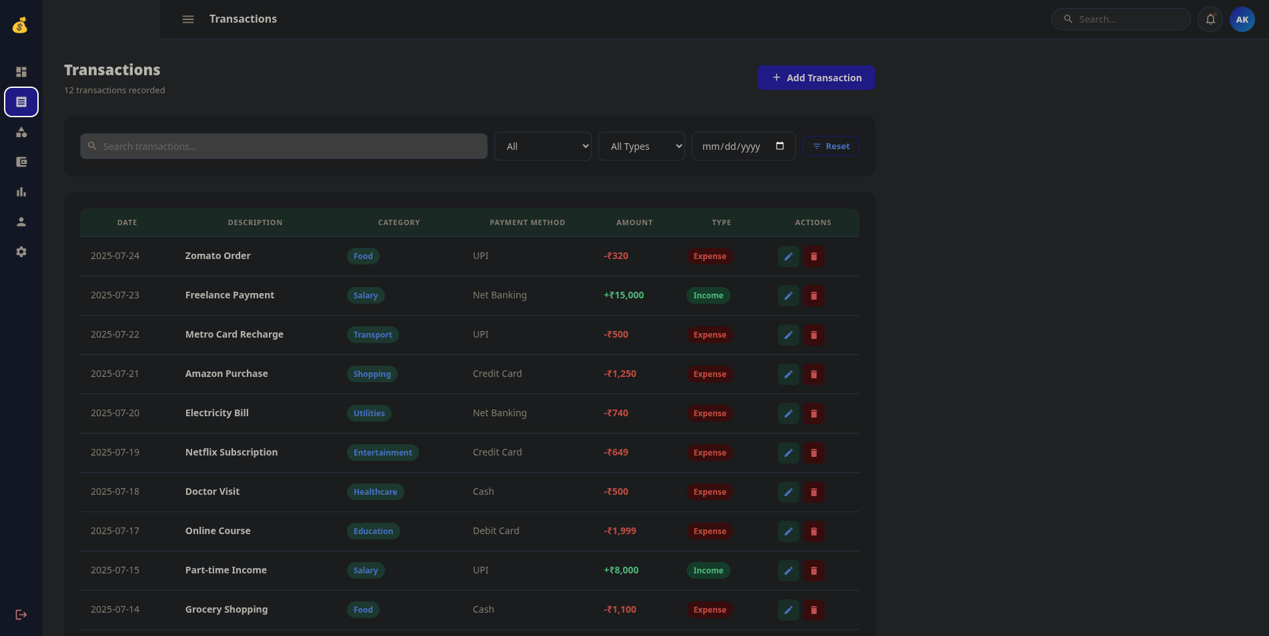
Categories and Budgets: Users can organize transactions into categories and set spending limits for specific periods.
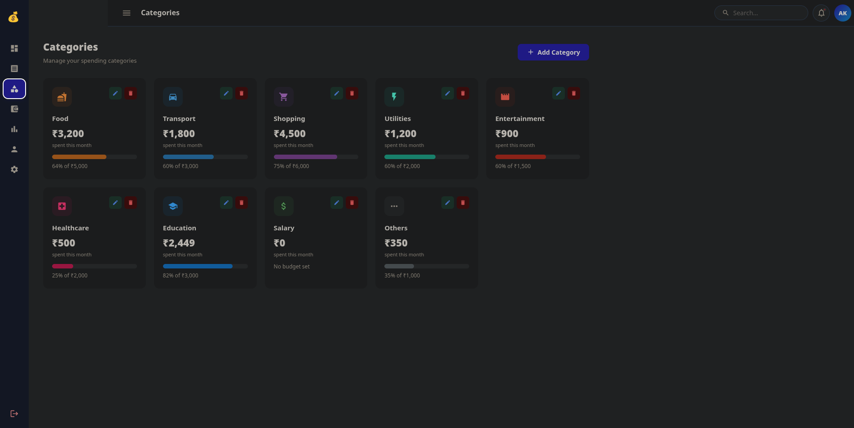
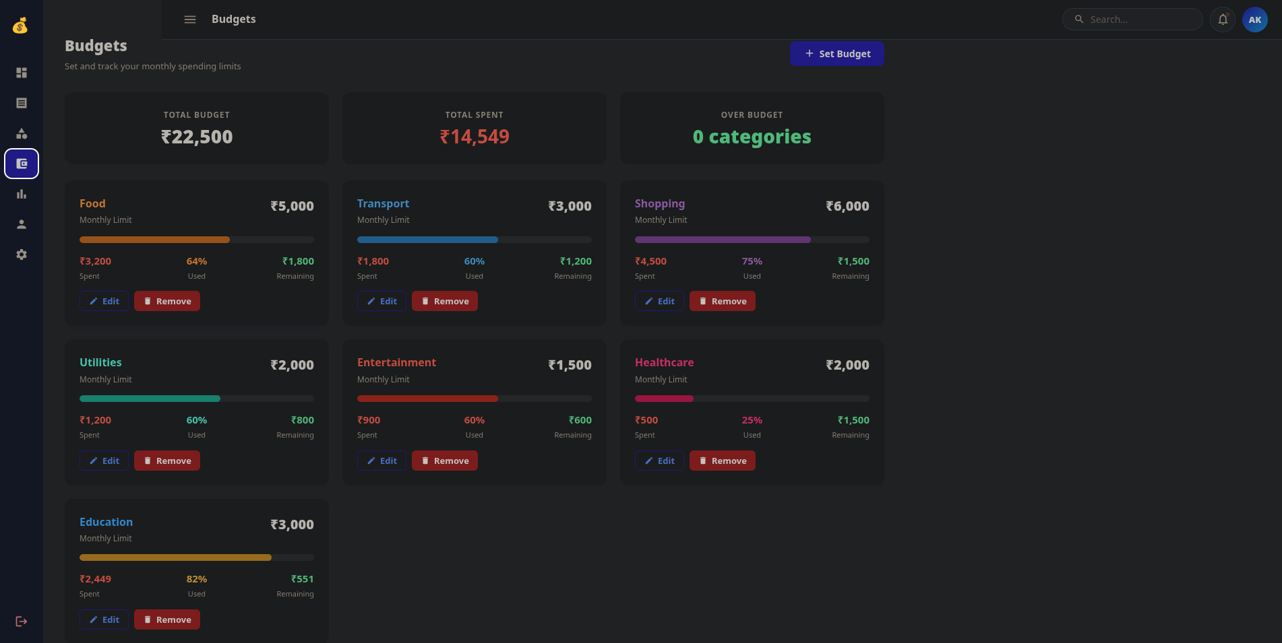
Search and Reports: Users can filter transactions by date, category, or type and view summaries of their financial activities.
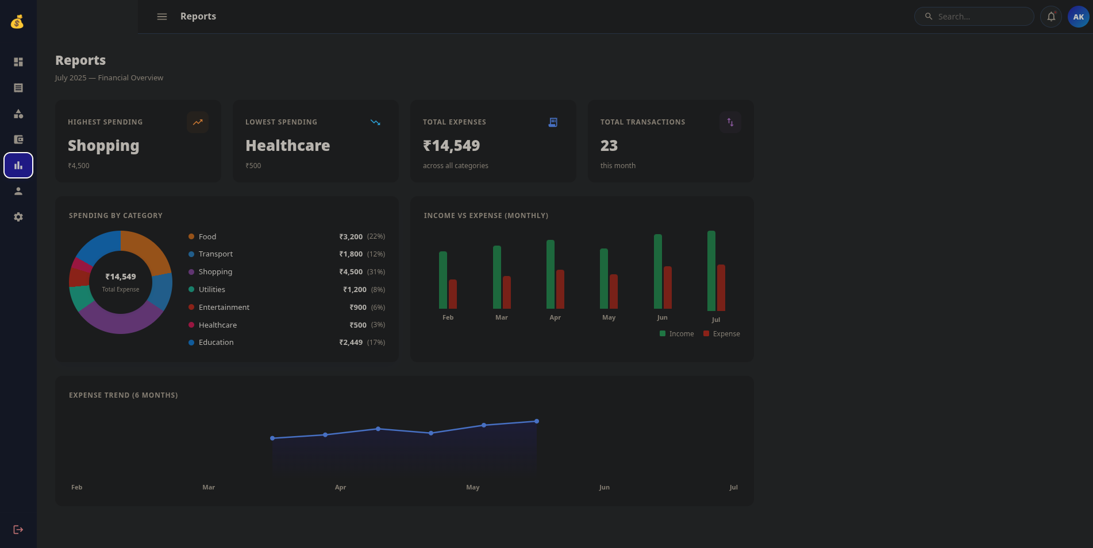
Profile and Settings: Provides options to manage profile details and account settings.

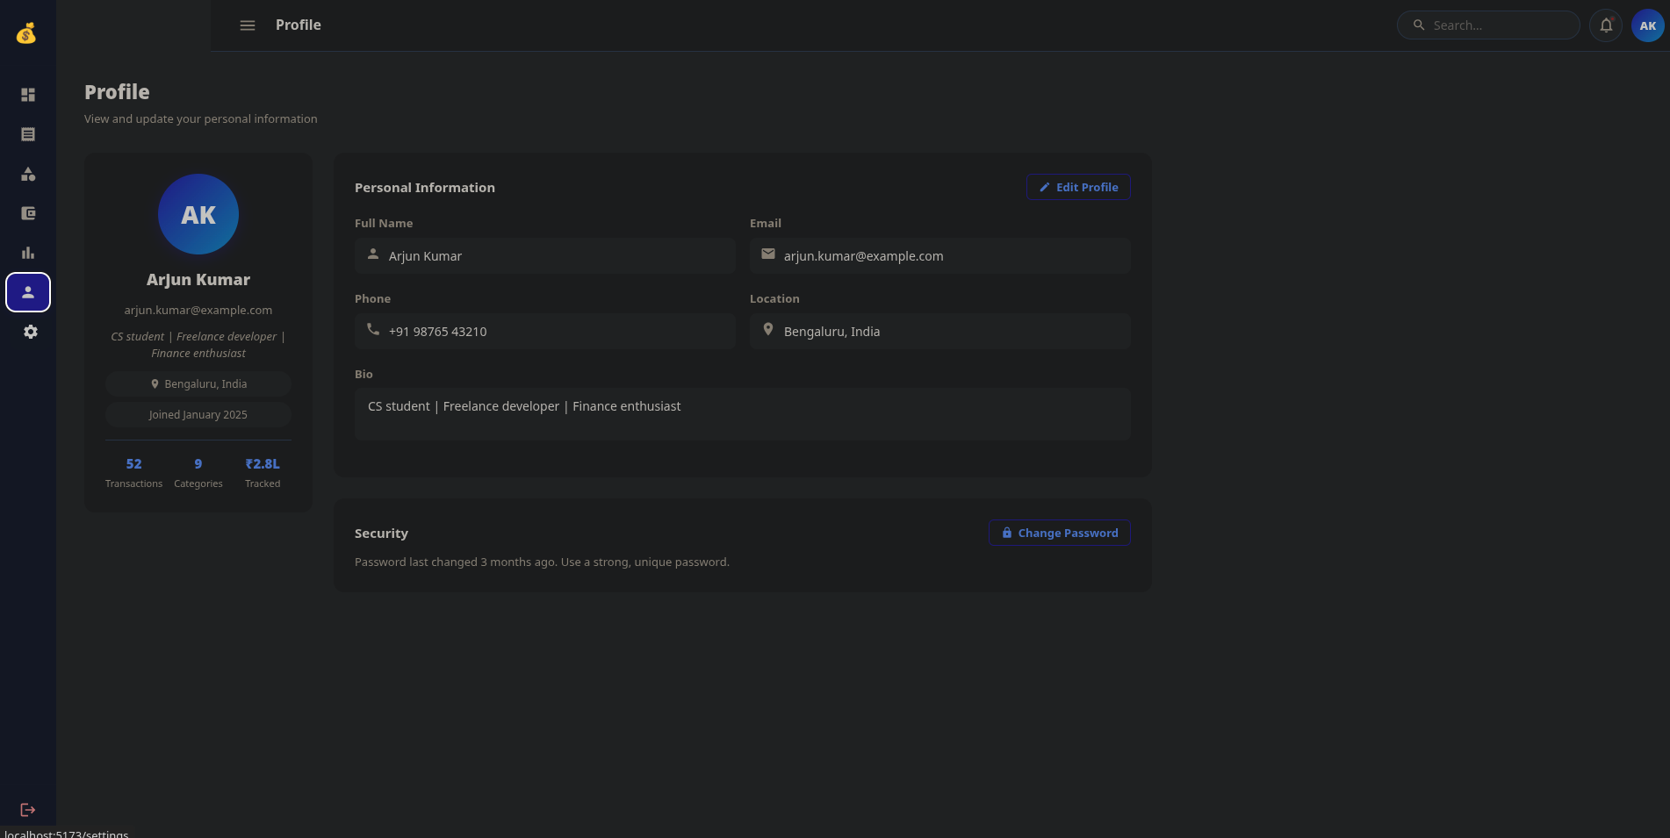
Navigation Flow: Login/Registration → Dashboard → Transactions, Categories, Budgets, Reports, Profile, or Settings.
The React frontend communicates with the Python backend, which processes requests and interacts with PostgreSQL to store and retrieve data. The interface uses forms for data entry and tables or summaries to display financial information.

5. Database Design
The database is designed using the relational model. Information is stored in four tables: Users, Categories, Transactions, and Budgets. Each table represents a specific part of the application, and relationships between tables are maintained using foreign keys.
Users
The Users table stores account details such as user ID, name, email, password hash, phone number, and account creation time. The user ID is the primary key, and the email address is unique.
Categories
The Categories table stores category details, including category ID, user ID, category name, category type, and description. Each category belongs to a user and is classified as either Income or Expense.
Transactions
The Transactions table stores financial records. It includes transaction ID, user ID, category ID, amount, transaction type, transaction date, description, and creation time. Each transaction is linked to its user and category. The amount must be greater than zero.
Budgets
The Budgets table stores budget details such as budget ID, user ID, category ID, budget amount, start date, and end date. It allows users to set spending limits for selected categories and periods. The budget amount must be positive, and the start date cannot be later than the end date.
ER Model and Relational Mapping
ER Diagram
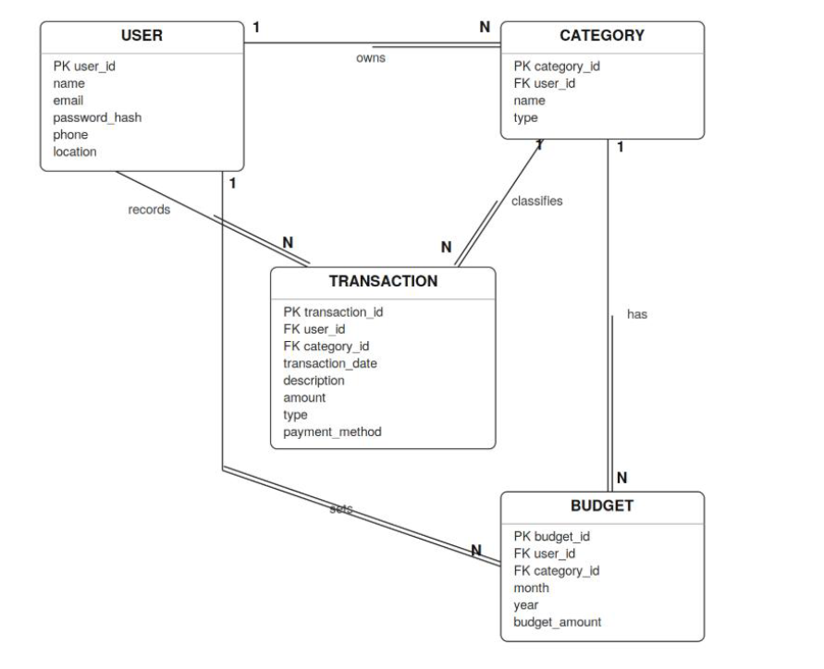
The ER model contains four entities: Users, Categories, Transactions, and Budgets. One user can have multiple categories, transactions, and budgets. A category can be associated with multiple transactions and budgets.
During conversion to relational tables, each entity is represented by a table. The primary key of Users is included as a foreign key in Categories, Transactions, and Budgets. The category ID is included as a foreign key in Transactions and Budgets. These relationships help maintain valid references between records.
The database also uses constraints to prevent duplicate email addresses, invalid transaction types, non-positive amounts, and incorrect budget date ranges. Category ownership is checked so that a user cannot assign another user's category to their transaction.
Relational Schema
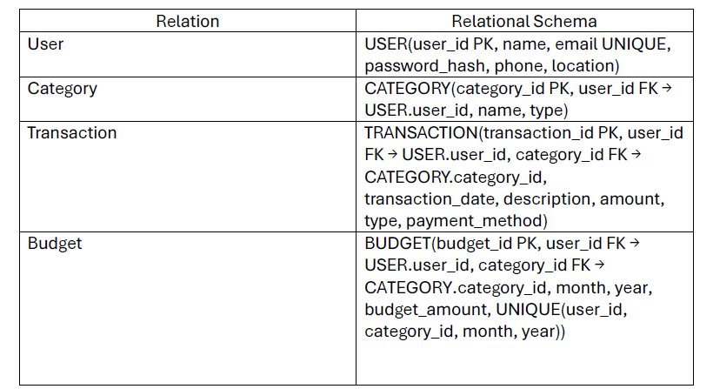
Relationship mapping:
• USER 1:N TRANSACTION is represented by TRANSACTION.user_id as a foreign key.
• USER 1:N CATEGORY is represented by CATEGORY.user_id as a foreign key.
• CATEGORY 1:N TRANSACTION is represented by TRANSACTION.category_id as a foreign key.
• USER 1:N BUDGET is represented by BUDGET.user_id as a foreign key.
• CATEGORY 1:N BUDGET is represented by BUDGET.category_id as a foreign key.
The Reports and Dashboard screens use aggregate queries over TRANSACTION and BUDGET rather than requiring separate stored relations.
Functional Dependencies
Functional dependencies describe how one attribute determines other attributes in a table. In this database, the primary key of each table determines the remaining attributes of that record.
- Users: user_id → name, email, password, phone, created_at
- Categories: category_id → user_id, category_name, category_type, description
- Transactions: transaction_id → user_id, category_id, amount, transaction_type, transaction_date, description, created_at
- Budgets: budget_id → user_id, category_id, budget_amount, start_date, end_date, created_at
Since email is unique, it can also identify a user record.

Normalization
Normalization is used to reduce unnecessary data duplication and avoid insertion, update, and deletion anomalies.
The tables satisfy First Normal Form (1NF) because each field stores a single value and each transaction is stored as a separate record. They satisfy Second Normal Form (2NF) because their primary keys consist of single attributes, so partial dependency on a composite primary key does not occur.
The design also follows Third Normal Form (3NF). User details are stored in the Users table, while category details are maintained in Categories. Transactions and Budgets refer to these records through foreign keys instead of repeating the same details. This reduces duplication and makes updates easier to manage.
Database Constraints and Indexes
Primary keys uniquely identify records, while foreign keys maintain relationships between tables. Unique constraints prevent duplicate emails and repeated category names of the same type for a user. Check constraints validate transaction types, positive amounts, and budget dates.
Indexes are created on commonly searched fields, such as transaction dates, user IDs, category IDs, and budget periods. These indexes help improve the performance of queries used for transaction history and financial reports.
6. Database Selection and Justification
PostgreSQL is selected as the database management system for the Personal Expense Tracker. It is an open-source relational database that supports SQL, constraints, transactions, indexing, and complex queries.
The project requires a database that can store related financial records and maintain consistency between users, categories, transactions, and budgets. PostgreSQL supports primary keys, foreign keys, unique constraints, and check constraints, making it suitable for these requirements.
It also provides aggregate functions such as SUM() that can be used to calculate total income, total expenses, and category-wise expenditure. These operations are useful for generating dashboard summaries and reports. Indexes can improve query performance when retrieving transactions for a particular user or period.
PostgreSQL supports transaction management, helping ensure that database operations are completed consistently. It also provides user roles and access controls. These features can be combined with backend authentication and authorization to protect financial information.
Another reason for selecting PostgreSQL is that it is freely available and integrates with Python through libraries such as Psycopg and SQLAlchemy. This makes it suitable for the project's backend without requiring a paid database licence.
Compared with SQLite, PostgreSQL is better suited to the project's intended shared-server, multi-user architecture. MySQL is also a suitable alternative, but PostgreSQL provides all the relational features needed for this implementation.
Overall, PostgreSQL provides a suitable foundation for storing financial data, maintaining relationships, and generating reports. Combined with React and Python, it supports the development of a structured and maintainable Personal Expense Tracker.

7. Implementation
The Personal Expense Tracker was implemented using React for the frontend, Python Flask for the backend, and PostgreSQL for database storage. The frontend sends requests to the Flask API, which executes SQL queries to store and retrieve user data.
Database Creation
The database was created in PostgreSQL with the name Personal_Expense_Tracker. Four main tables were created: users, categories, transactions, and budgets.
The schema.sql file contains the SQL statements for creating these tables and defining their relationships.
CREATE DATABASE "Personal_Expense_Tracker";
The database schema includes primary keys, foreign keys, unique constraints, and check constraints to maintain data integrity.
Table Creation
The users table stores user details and hashed passwords. The categories table stores income and expense categories. The transactions table records financial transactions, while the budgets table stores monthly spending limits.
Example SQL statement:
CREATE TABLE users (
user_id BIGINT GENERATED ALWAYS AS IDENTITY PRIMARY KEY,
name VARCHAR(100) NOT NULL,
email VARCHAR(255) UNIQUE NOT NULL,
password_hash VARCHAR(255) NOT NULL,
phone VARCHAR(20),
location VARCHAR(100),
created_at TIMESTAMP DEFAULT CURRENT_TIMESTAMP
);
Output: The users table is created with a primary key and a unique constraint on email.
Constraints and Data Integrity
Constraints are used to prevent invalid or duplicate data.
- Primary keys uniquely identify each record.
- Foreign keys connect transactions and budgets to users and categories.
- Unique constraints prevent duplicate email addresses and repeated budgets for the same category and month.
- Check constraints ensure that transaction amounts and budget amounts are positive and that transaction types are valid.
For example:
CHECK (amount > 0)
Output: Transactions with zero or negative amounts are rejected by PostgreSQL.
Sample Data and SQL Queries
The application creates default categories when a user registers. These include Food, Transport, Shopping, Utilities, Salary, and others.
The following query retrieves transactions along with their category names:
SELECT t.transaction_id, t.transaction_date,
t.description, t.amount, c.category_name
FROM transactions t
JOIN categories c
ON t.category_id = c.category_id;
Output: The query displays each transaction with its corresponding category. 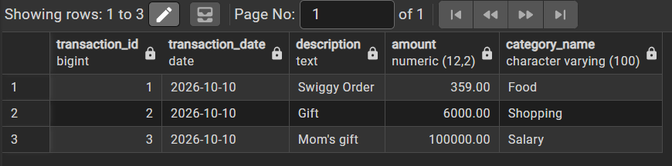
CRUD Operations
The application supports the basic database operations through its interface.
- Create: Add transactions, categories, and budgets.
- Read: View transactions, categories, budgets, and reports.
- Update: Edit existing transactions, categories, and budgets.
- Delete: Remove transactions and categories.
These operations are handled by Flask routes that execute SQL statements in PostgreSQL.
For example, the following query retrieves all transactions belonging to a particular user:
SELECT *
FROM transactions
WHERE user_id = 1;
Output: Displays only the transactions associated with the specified user.
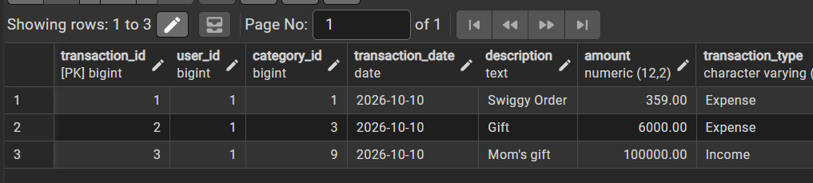

8. Testing & Validation
The application was tested to check whether its main functions work correctly and whether invalid data is handled properly.
Test case |  | Input / Action | Expected output | Actual result
User registration |  | Enter valid details and a password of at least 8 characters | Account is created successfully | Pass
Duplicate registration |  | Register again using the same email | Duplicate account is rejected | Rejected
User login |  | Enter valid credentials | User is logged in | Pass
Invalid login |  | Enter an incorrect password | Login is rejected | Rejected
Add transaction |  | Enter a valid amount, date, type, and category | Transaction is saved | Pass
Invalid transaction amount |  | Enter zero or a negative amount | Transaction is rejected | Rejected
Category management |  | Add or edit a category | Category details are updated | Pass
Budget management |  | Set a valid budget amount | Budget is saved | Pass
Duplicate budget |  | Add another budget for the same category and month | Duplicate budget is rejected | Rejected
Delete transaction |  | Delete an existing transaction | Transaction is removed | Pass

User Registration and Duplicate Registration
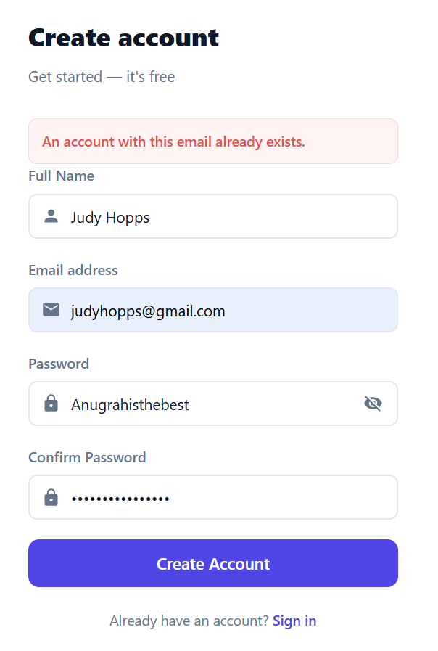
User login and Invalid login
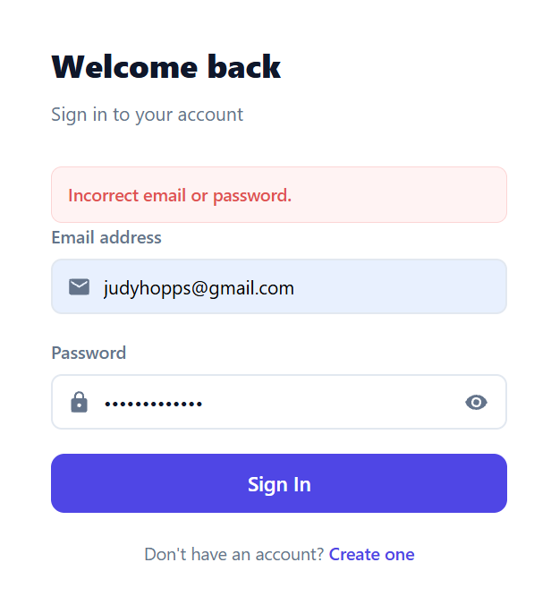
Valid and Invalid addition of transaction
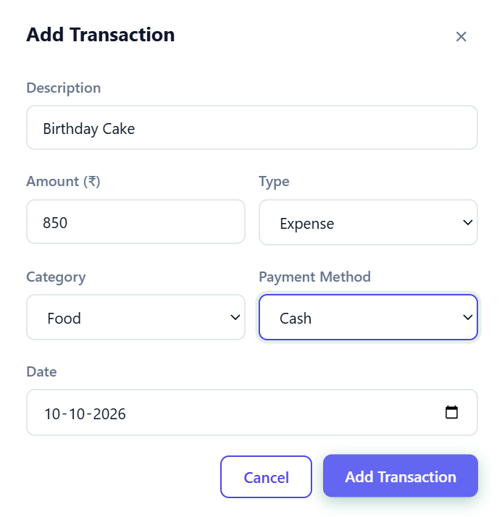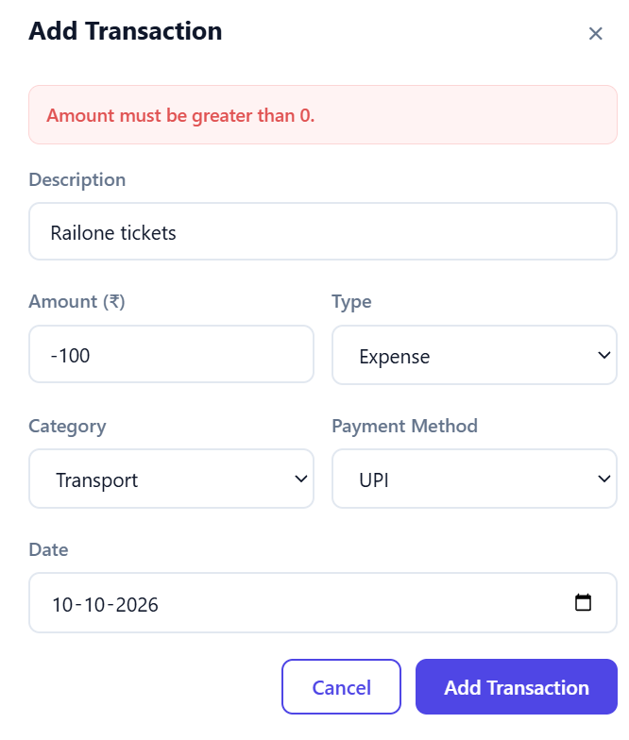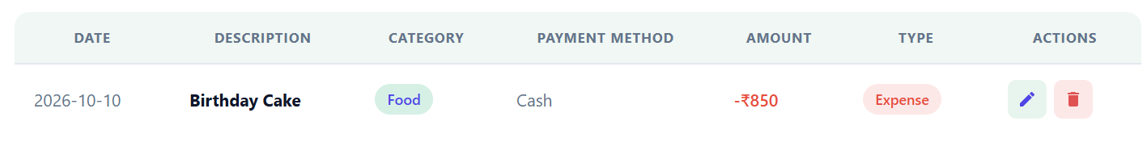

Category Management
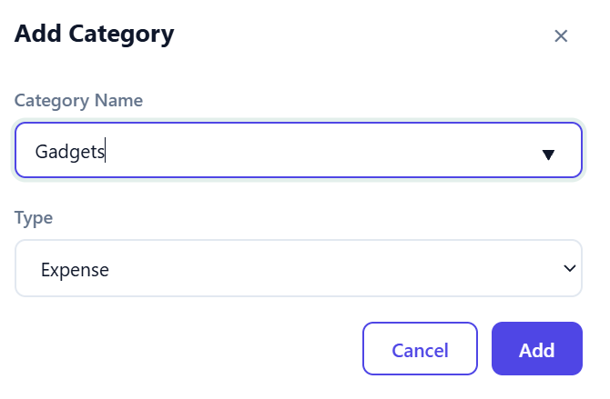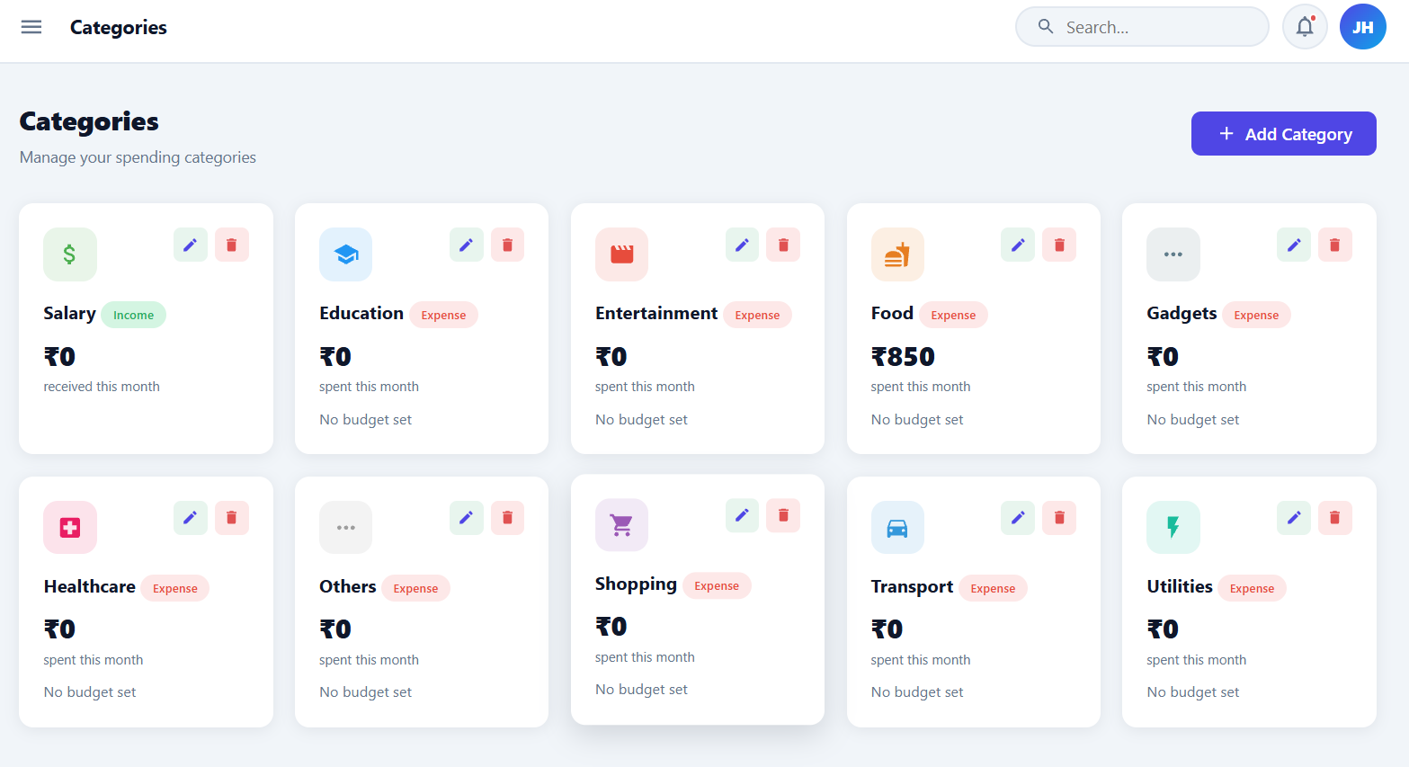
Budget Management
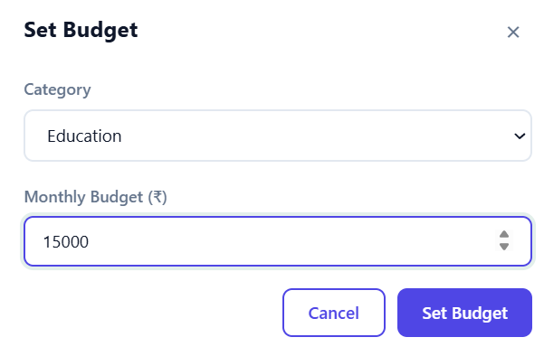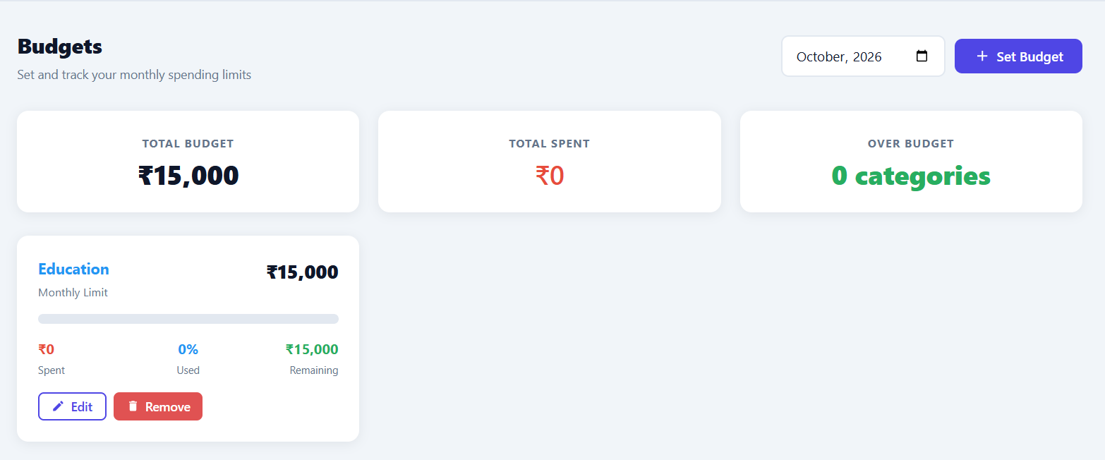
Invalid Budget
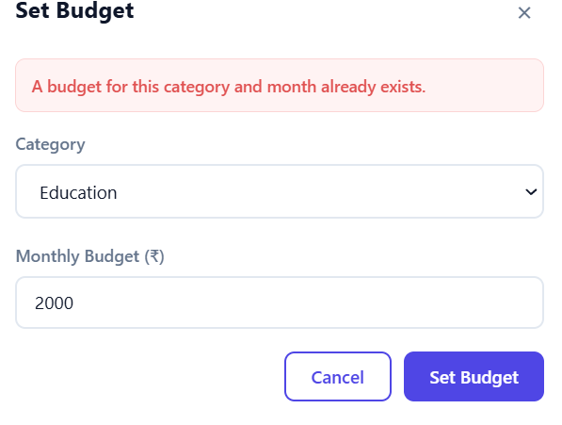

Transaction deletion
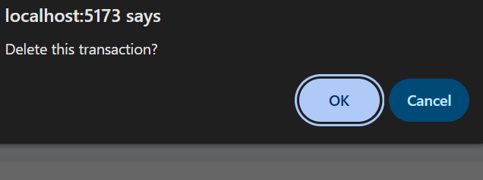
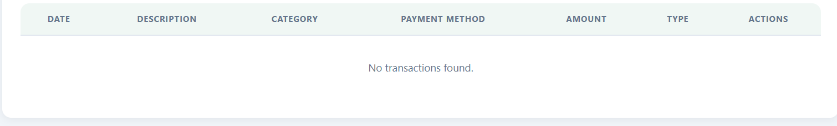
Constraint Validation
The following query can be used to verify that transaction amounts are positive:
INSERT INTO transactions
(user_id, category_id, transaction_date, amount,
transaction_type, payment_method)
VALUES (1, 1, CURRENT_DATE, -100,
'Expense', 'Cash');
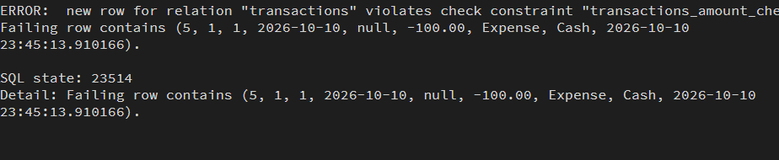
Expected output: PostgreSQL rejects the insertion because the amount violates the CHECK (amount > 0) constraint.

9. Results & Screenshots
The Personal Expense Tracker provides an interface for managing financial records, organizing categories, setting budgets, and viewing expense summaries. Screenshots of the implemented features and database operations are included to demonstrate the working system.
Dashboard
Shows the main dashboard with the financial summary, total income, expenses, balance, and recent transactions.
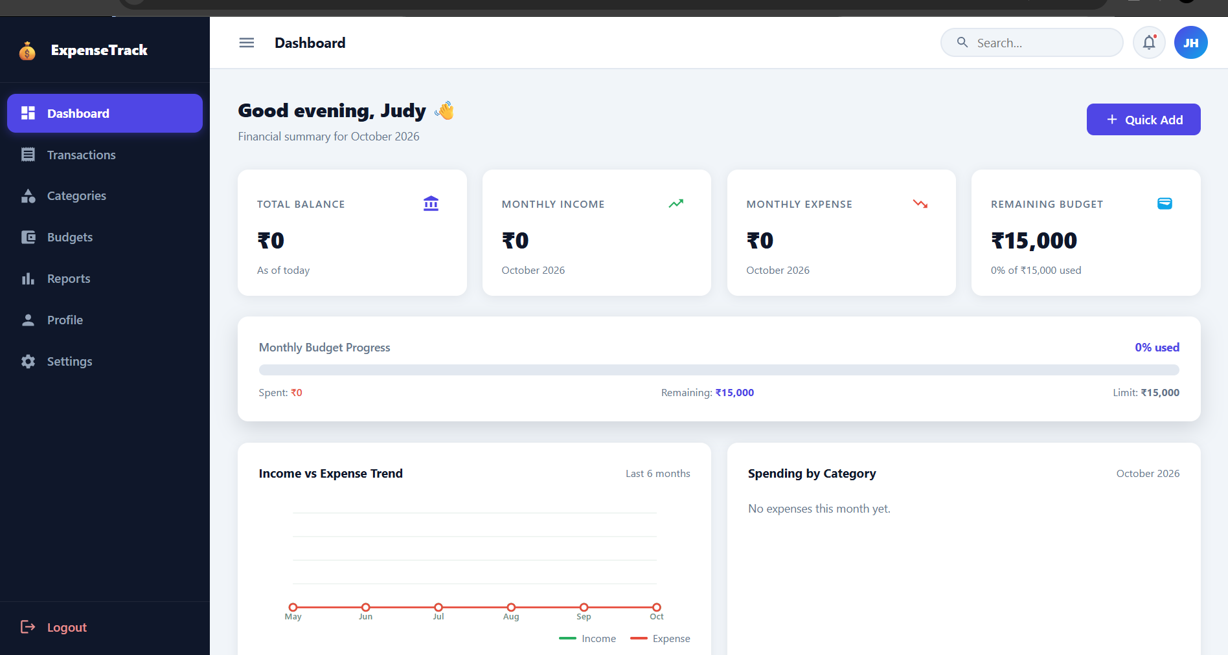
Transaction Management
Shows the transaction form or transaction list used to add, view, edit, and delete financial records.
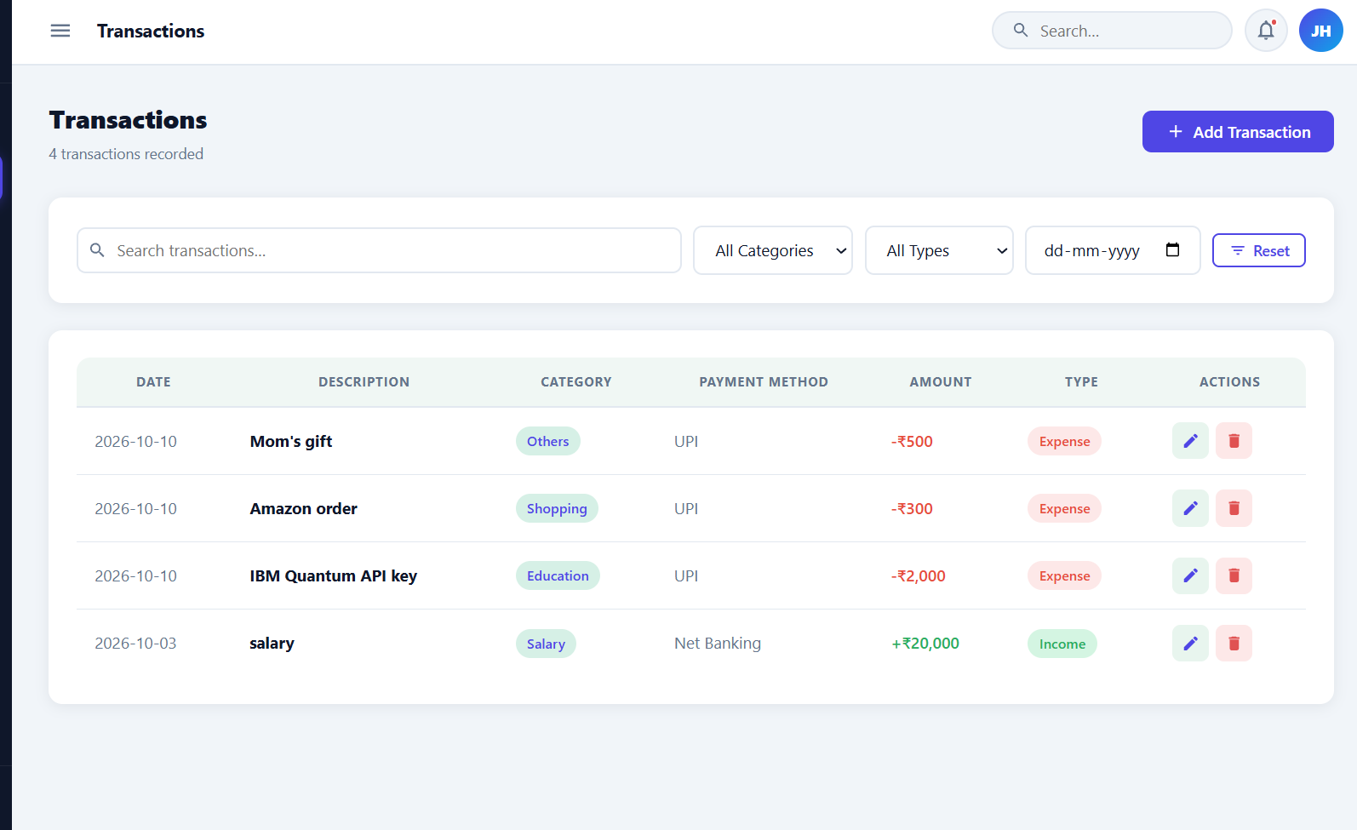
Budget Management
Shows the budgets created for different expense categories and the corresponding spending information.
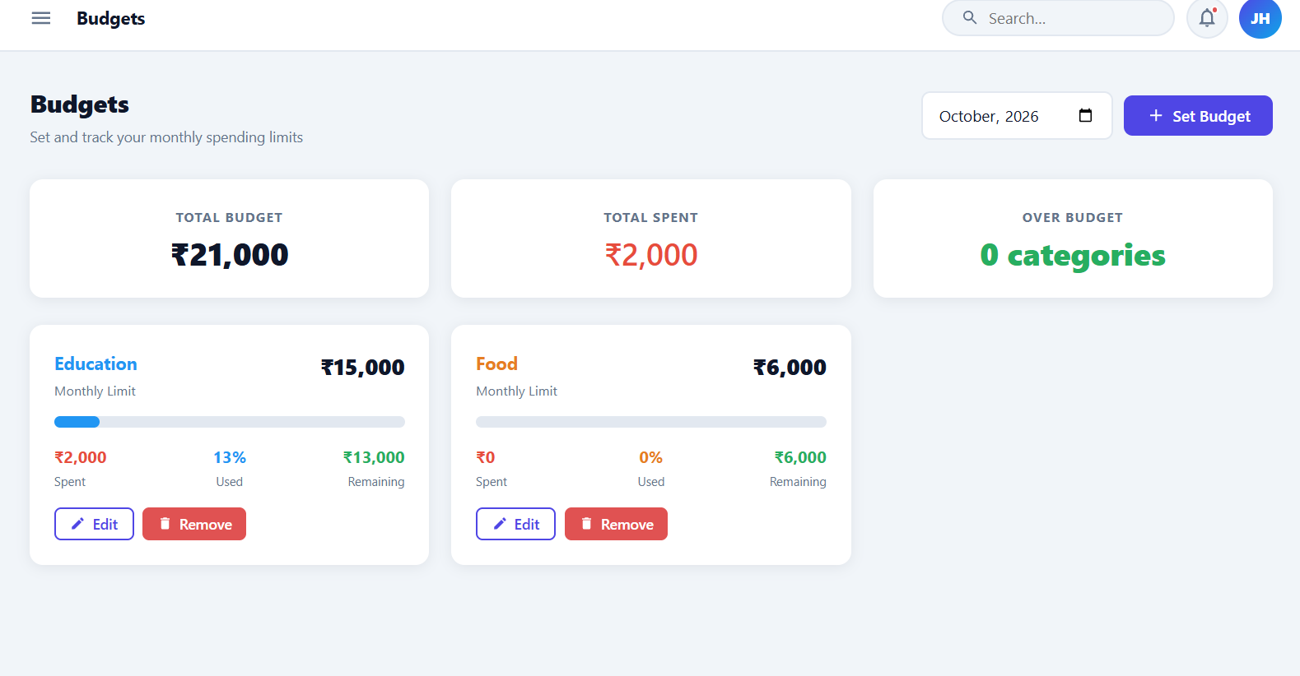
Database Tables in PostgreSQL
Shows the four tables created for the project: users, categories, transactions, and budgets.
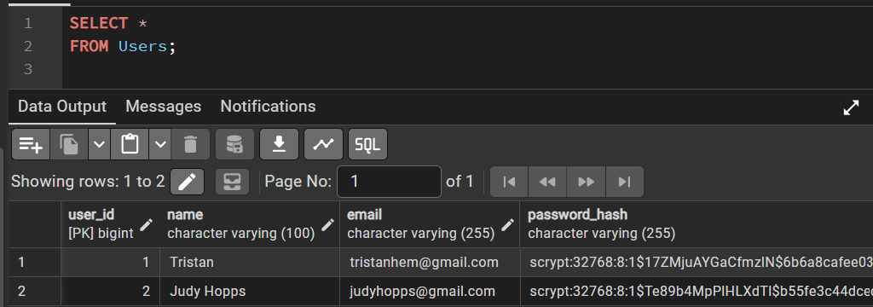

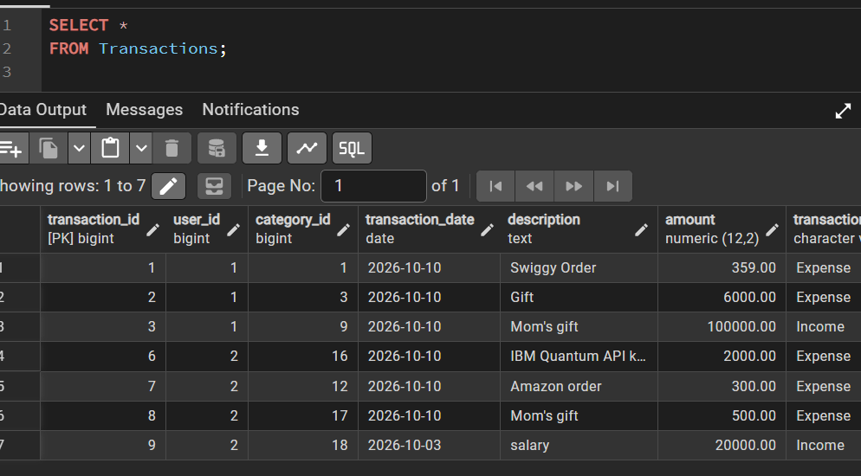
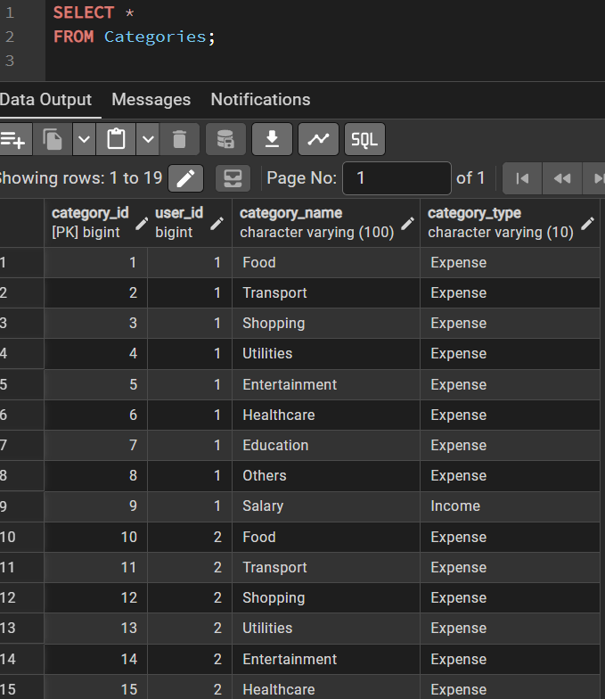
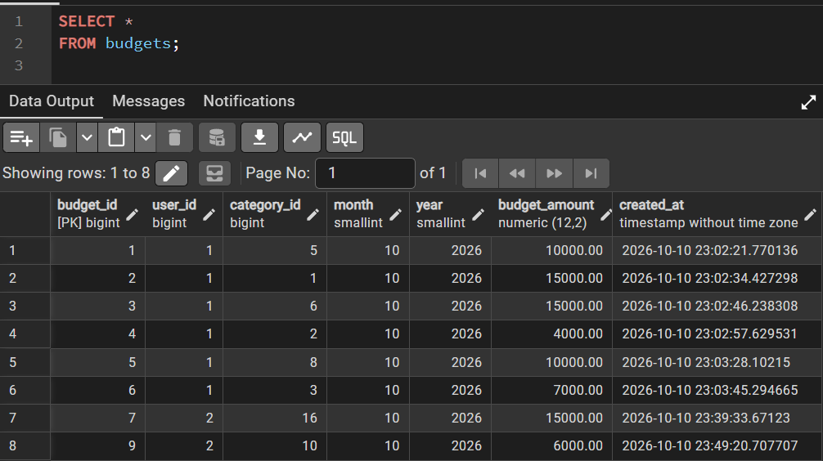

10. Challenges Faced & Solutions
During the development of the Personal Expense Tracker, several challenges were identified in database design and application integration.
- Database Design: Establishing relationships between users, categories, transactions, and budgets required careful planning. Primary and foreign keys were used to maintain these relationships.
- Data Redundancy: Repeated storage of user and category details could lead to inconsistencies. Normalization was applied to organize data into separate tables.
- Data Validation: Invalid amounts and incorrect date ranges could affect financial records. Check constraints were used to validate the data.
- Frontend and Backend Integration: Connecting the React interface to the Python backend and PostgreSQL database required consistent data formats and proper request handling.
- Data Security: Financial information must remain private. Password hashing and user authorization are important for protecting user accounts and records.
11. Conclusion & Future Enhancements
The Personal Expense Tracker provides a structured approach to managing personal income, expenses, categories, and budgets. PostgreSQL is used to store related information, while Python handles backend operations and React provides the user interface. Relational tables, keys, constraints, and normalization help maintain data consistency and reduce redundancy.
Future enhancements may include recurring transaction management, budget alerts, mobile application support, cloud deployment, data export, improved authentication, and advanced spending analysis. Database query optimization and additional reporting features could also improve the system as the amount of stored data increases.
References
- PostgreSQL Global Development Group. PostgreSQL Documentation. https://www.postgresql.org/docs/
- React Team. React Documentation. https://react.dev/
- Python Software Foundation. Python Documentation. https://docs.python.org/3/
- Bootstrap Team. Bootstrap Documentation. https://getbootstrap.com/docs/
- Elmasri, R., and Navathe, S. B. Fundamentals of Database Systems. Pearson.
- Psycopg Team. Psycopg Documentation. https://www.psycopg.org/psycopg3/docs/

